1. A screenshot of a computer

   Description automatically generatedThe application form must be the same as cruisepay. The only difference is that we must ask only for passports, the other documents we are asking them in next stage. Also, this stays the same

2.

We need to communicate with client if we reject them .. for more info.

3.

We don’t need this because we ask for the passport in the first stage

4. The View button needs to work in each stage. The client need to see the document he uploads. Also, we can have a preview button for the client to see what he complete in each form and what he uploads.

5. we can add reject client button.

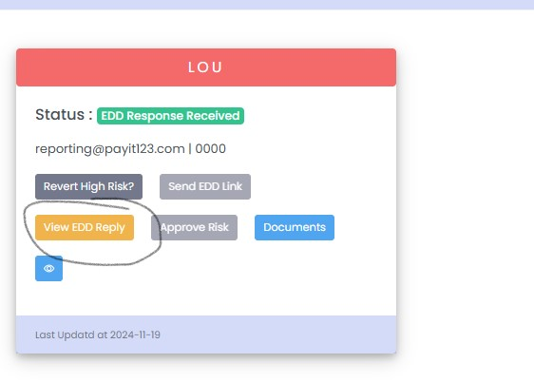6.

when we send a clarification question and the client answer it will be more convenience for us if a message symbol or something it will appear